TechnoSystems Public Limited is a successful software company that specializes in operating systems. It sees an opportunity to expand into a new niche software sector, productivity applications. LittleCo is a small unlisted company that has developed award winning products in the productivity applications domain, but does not have much of a brand name or customer base yet. It has emerged as a candidate for acquisition by TechnoSystems. How would you value the firm? How would you plan the post-merger integration?

An acquisition occurs when one company buys another company, or a business of that other company. A merger occurs when a new company is formed and the acquirer and target companies are dissolved. Mergers and acquisitions (M&A) are different for tax purposes and similar for many strategic purposes. We focus on their commonalities rather than differences and will mostly use the term “acquisitions” to talk about both.

There are several stages in the M&A process involving people and experts from within and outside the acquirer-target firms: target selection, valuation & negotiation, due diligence, integration, and post-deal evaluation (see Figure 12.1).

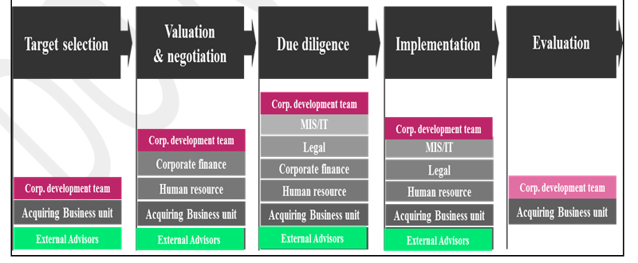
Figure 12.1 Stages and people in an M&A process

Much of the strategic thinking on when to do an M&A (as opposed to an alliance or organic growth), described in sections 4, 5 and 6, must be completed before beginning the first step of the M&A process, target selection. During the valuation & negotiation phase the acquirer estimates how much the target is worth and finds a price that is acceptable to both. Due diligence refers to a period in which the acquirer, having made an offer, is granted access to private data by the target to verify its valuation. Implementation refers to the process of achieving the desired level of integration of activities across acquirer and target in order to extract synergies. Evaluation refers to post-transaction review of what went right and wrong. This is particularly useful for serial acquirers whose transactions tend to be similar enough to apply learning from prior transactions onto future transactions.

There are enormous technical complexities at each stage, and in all likelihood, professional outside advisors (investment bankers, consultants, lawyers, and technical experts) will be involved. Our aim is to give the reader a map of the terrain, and a broad framework to bound and manage this complexity.

Both the valuation & negotiation as well as post-merger integration activities in a corporate acquisition depend on the underlying synergies in the transaction, which is why we focus on these. Ideally, these two activities should also depend on each other—the valuation must take into account the anticipated post-merger integration challenges, and the post-merger integration activities must be mindful of the value drivers in the valuation.

Valuation & negotiation: How much should you pay for a company?
Valuing a company, particularly for the purposes of acquiring, is a quantitative exercise. At the same time it is quite subjective (because it depends critically on assumptions about an uncertain future based on limited information). In this section we offer several guidelines to help navigate the uncertainties of valuation. We cannot significantly reduce the uncertainties in valuation, but we can develop a disciplined way of taking these into account, of documenting the assumptions we make in dealing with uncertainty, and engaging in a reasonable bargaining process, to ultimately lead to a price to which both parties agree.

The first point to realize is that valuation is an iterative process. In arriving at the decision to acquire, a systematic approach such as we recommended in sections 4, 5, and 6, would already have made at least some approximate estimates of the value to the company from acquiring vs. allying vs. organic growth. Once the acquisition alternative has been finalized and a target has been shortlisted, we may use those estimates as a starting point and refine them.

Second, valuation as a process for figuring out how much the target is worth to the acquirer—is different from the process of deciding what to pay for the target—which typically involves a process of bargaining and negotiation. Valuation helps to set the upper and lower bounds on what the acquirer should be willing to pay (and the target should be willing to accept). What an acquirer finally pays will be also be determined by the relative bargaining power and skill of the target (see Figure 12.2).

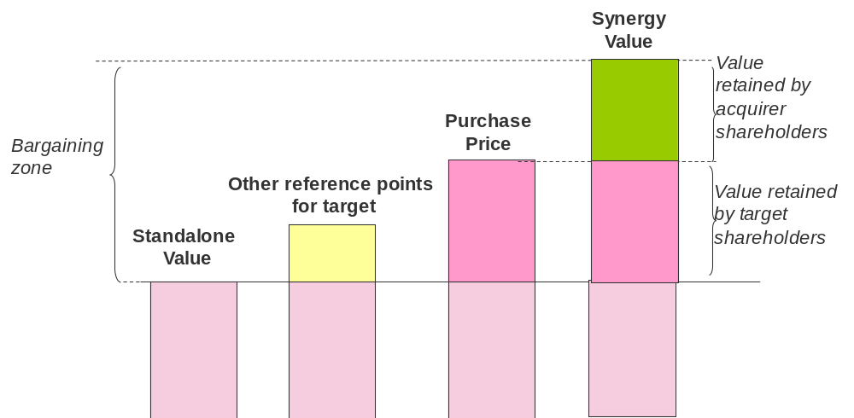
Figure 12.2 Valuation sets the lower and upper bound for negotiation

The lower bound in a valuation process is determined by the stand-alone value of the target firm. This is what the target firm would be valued at by an acquirer with zero synergies of acquiring the target (and effectively ignores the costs of integration that are synergy independent, more on this below). It represents a hypothetical benchmark, and any offer below this would be rejected by the target firm unless the acquirer spots a bargain that even the target firm management cannot see or is unwilling to see.

If the target firm is listed in an efficient capital market (and it is not yet widely known that the target firm may be in play), the current market capitalization of the firm is a good indicator of the equity value. Equity plus the firm’s debt (and minus cash balances) gives the stand-alone enterprise value. If there is no market price or the price does not reflect well the underlying value, some other commonly used techniques include:
- Intrinsic valuation: Analyze what a firm is worth by considering what assets it has or will have in the future. Measures include:
  - Net Present Value of future cash flows: estimate the cash flows that the target company would generate if operated on a stand-alone basis. Next, discount those cash flows to take into account the riskiness and the timing of those cash flows. Often cash flows are detailed for only a limited period (say the next 5 or 7 years) and any subsequent cash flows are grouped together in a terminal value based on some blanket assumptions on growth and investment requirements.
  - Balance sheet metrics: Use document value, i.e. what is given on the balance sheet. This works better if a company’s most valuable assets are indeed on the balance sheet, e.g., physical capital but not human capital. This method is not forward looking. Alternatively, liquidation value of the target company could be used. This is the expected price of physical assets in a quick sell.
- Relative valuation: Analyze what a firm is worth by comparing with other firms.
- Earnings multiples: From the income statement, obtain the target’s EBITDA (earnings before interest, tax, depreciation and amortization) and multiply by the ratio of enterprise value to EBITDA for a comparable, standalone listed company. This assumes that the target company and peer firm have similar expected growth rates and risk. It is better to use enterprise value than equity value to eliminate differences in capital structure (i.e., debt vs. equity).
- Revenue multiples: Use the targets revenue and multiply by the enterprise value / revenue ratio for a comparable, standalone listed company.
- Other multiples: Sometimes using earnings multiples is not feasible (e.g., loss making companies) nor revenue multiples (e.g., young companies). Other multiples include document value, or more creative (and sometimes less reliable) multiples involve comparing the number of customers.

The upper bound for the valuation of the target company is its synergistic value, or stand-alone value + the value of synergies with the acquirer. To estimate this synergistic value of the target, we can use the Net Present Value of future cash flows of both the Target + Acquirer after taking into account the effects of synergies between them as well as the costs of extracting them. The Appendix to Section 2 provides details on how to value synergies using value drivers and NPV.

As an additional reference point to estimate the value of synergies, one may also compute the premium over standalone value offered in prior acquisitions between similar acquirers and targets (also called deal multiples), and apply this to the standalone value of the target firm. Two points are worth emphasizing here: First, EBITDA or revenue multiples help estimate standalone value, whereas deal multiples help to estimate synergistic value. Second, these multiple based valuation methods are approximate; no pair of acquirer and target firm is identical. Nothing beats NPV with good information but good information about an uncertain future is difficult, if not impossible, to obtain. Hence, it is useful to also look at deal multiples. They may also serve as a bargaining tactic, more below.

The synergistic value of the target can be broken down in a few different ways, which allow one to be more conservative by ignoring certain parts of the synergistic valuation when setting the upper bound on the valuation. These include:
- Synergistic value of target = Standalone value of target + NPV(Synergy impact on target) + NPV(Synergy impact on acquirer)
- Synergistic value of target = Standalone value of target + NPV(Synergy from Consolidation) + NPV(Synergy from Combination) + NPV(Synergy from Connection) + NPV(Synergy from Customization)

These break-ups help to be conservative in the actual bidding and deal closing stage, as the upper bound can be set not at Synergistic Value of Target, but instead at Standalone value of target + some portion of the synergy value (e.g. ignoring synergy impact on acquirer, ignoring all synergies other than consolidation, or discounting the more uncertain synergies at a higher discount rate than the target’s weighted average cost of capital). No matter which synergies are prioritized, integration costs should be taken into account. These refer to the costs of making the organizational changes in target and acquirer to create a new combined organization and to help extract synergies.

Integration costs can be separated into synergy dependent and synergy independent integration costs. Synergy independent costs of integration do not depend on the type or value of the synergy being extracted through integration, but instead depend on the scale and age of the target organization. All else being equal, larger and older organizations, regardless of the nature of the synergies involved in the deal, will require greater integration efforts to convert their systems and processes to be compatible with the acquirer, and to separate and divest unwanted assets. Synergy dependent costs of integration depend on the kind of synergies being extracted; they may be thought of as a variable tax that eats into the value of the synergy. If no synergy is extracted, then there are no integration costs of this kind. As we noted in Section 2, we can make some informed conjectures about the differences between the integration costs (as a percentage of synergy value) as well as the uncertainty associated with each type of synergy.

Between the upper bound (synergistic value) and lower bound (stand-alone value) of the target firm lies a bargaining zone, within which acquirers and targets may hope to find a point of agreement. Each side may of course use bargaining tactics, such as the use of other valuation benchmarks, to push the price in their respective favor. For instance:
- Targets can use (potential) offers from alternative bidders to get acquirers to raise the offer price
- Acquirers and targets may use historical transactions of broadly comparable targets, or standalone value of broadly comparable targets to justify their preferred value of premium over stand-alone value
- Acquirers may estimate the cost of organic growth—what it would cost them to build internally—to set a ceiling on what they are willing to pay
- If the target is unlisted, the estimated valuation of the target firm on IPO may be another benchmark the target can use to improve its bargaining position
- Listed target firms may use their historically higher share prices to argue that their current share price does not accurately reflect its standalone value

There are many financial complexities to valuation, including estimating the cost of capital and financing the transaction, for which we refer readers to others sources. The key points about valuation that a corporate strategist must know are what we have covered. The essence is simple—valuation is not about finding the “true” value of the target firm—it is about finding a number that all sides are happy with. It is (sophisticated) guesswork, it is negotiated, and it is about a range rather than a point estimate. This does not mean the quantitative analysis serves no purpose; it does. It offers a disciplined language for the negotiation to take place in.

Post-merger integration: How much should you integrate both companies?
At a fundamental level, the problem of post-merger integration (PMI) is essentially an organization design problem. A new common organizational structure must be designed and implemented that brings the acquirer and target organization together. It involves going from two organizations with distinct structures (both formal and informal) to a new common organization, and one that enables the exploitation of the synergies that motivated the acquisition in the first place. It is also, interestingly, an organization re-design problem largely free of the baggage (or benefits) of an informal organization; except in the case of an alliance converting into an acquisition, the two organizations are often strangers to each other before the deal.

PMI planning ideally commences at the stage of valuation (as the synergies that are being valued must be the ones that are extracted through PMI) and is completed before the formal completion of the deal, at which point the post-merger integration plans are implemented. A separate program management office may then be created to oversee the post-merger integration process, with a host of post-merger integration projects targeted at the extraction of particular synergies. We focus on the planning of the post-merger integration process, the key decisions to be made, and trade-offs to be considered.

There are several known challenges to post merger integration that researchers and managers are aware of. These include:
- Complexity: This is a function of the number of inter-related decisions on tradeoffs to be made and implemented, which increase with the size of the target as well as the type of synergy (higher for synergies requiring significant modification to resources, such as customization and consolidation).
- Limited information: Many of the decisions that are premises in the post-merger integration planning phase are made without accurate information. These include decisions about synergies and valuation. It is only when post-merger integration commences that more detailed information emerges, which may sometimes invalidate assumptions and decisions made earlier in the process of the acquisition.
- Functioning while integrating: A post-merger integration expert once remarked in our class that post-merger integration was a bit like trying to change the engine in a plane while it was flying. Keeping business running as usual while engaging in a complex integration process can be extremely difficult, and may lead to a lack of attention by the senior management towards pressing issues of competition.
- Uncertainty and change: Post-merger integration implies uncertainty and change for employees. Independent of whether the new circumstances leave them better or worse off, the period during which they do not know about their new circumstances can be very stressful. This lowers productivity and may lead to turnover. Assuming job mobility is higher for more talented and qualified employees, a period of uncertainty can actually leave the acquirer with a target organization from which the best human capital has departed.
- Cultural differences: The acquirer and target typically differ not only in their formal structures, but also in their organizational and possibly national cultures. These differences can impede collaboration across organizations and create conflict.

Choosing the level of integration involves balancing the benefits from collaboration with the costs of disruption
In post-merger integration we need to balance two consequences when deciding on organizational integration levels - the need for collaboration, and the need for minimizing disruption (see Figure 12.3). There is considerable evidence from research on the existence of this trade-off.

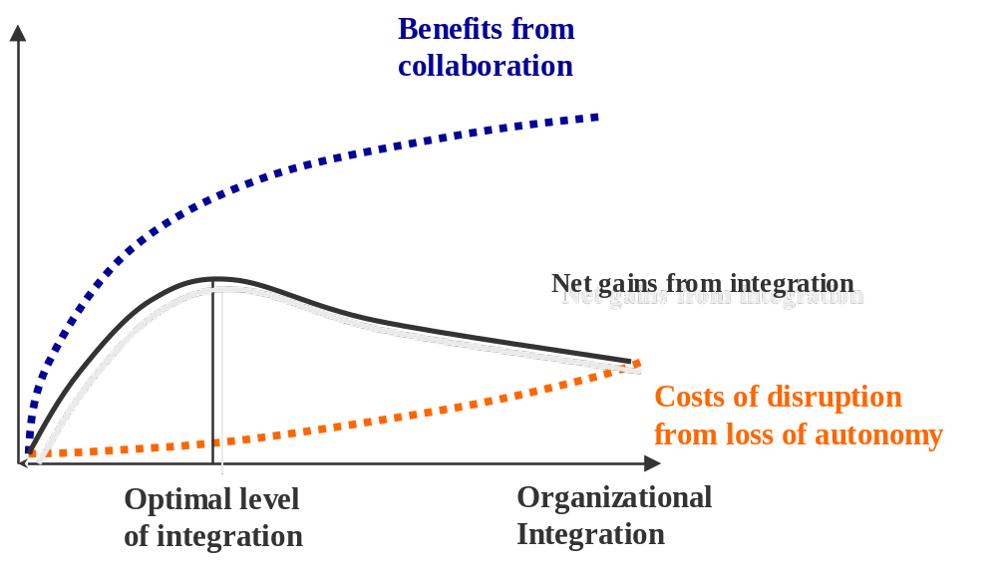
Figure 12.3 The fundamental trade-off in post-merger integration between collaboration and disruption

Note that we are interested in reducing disruption not only because we care about how employees feel after being acquired, but also because we care about the impact of the disruption on their productivity—a case of enlightened self-interest. Thus choosing an optimal level of integration requires trading off the benefits from collaboration against the costs of disruption.

In general some degree of integration is necessary to get synergies in acquisitions (and it is precisely the ability the extract synergies that distinguishes a corporate strategist from pure investors, see Section 1), though how much will vary from case to case as a function of the benefits from collaboration, and the implementation competence of the acquirer at managing the costs of disruption. For instance, the benefits of integration may rise and peak faster for some types of synergies—particularly those that require limited modification of resources across value chains (e.g. connection, combination). These types of synergies may, all else being equal, require lower levels of integration than synergies involving consolidation or customization. It may also be the case that the costs of disruption for the same level of integration may vary with similarity of cultures between acquirer and target, or the ability of the acquirer to implement a given level of integration very smoothly.

Grouping and linking are the key integration choices
We can think about the post-merger integration decision regarding the combined organizational structure, in terms of two sequential choices: one about grouping (into organizational units such as departments with a common boss, incentives, and procedures, i.e. the boxes in an organization chart) and the other about linking activities across groupings (such as vertical reporting, dedicated liaisons, and temporary task forces, i.e. lines in organization charts). This follows from Section 10, in which we explained that grouping and linking are the two key choices for organizational design (see Figure 12.4).

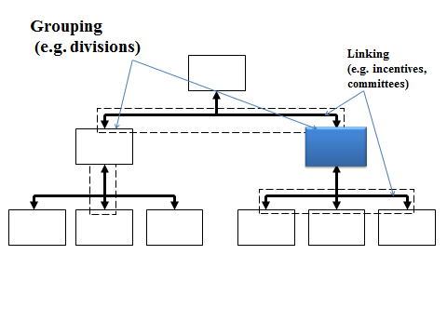
Figure 12.4 Grouping and linking

- Grouping choices
Consider two organizational units, one from the target T, one from the acquirer, A. What are the different levels to which these two could be organizationally integrated after an acquisition? The first choice is about grouping these units together with the following options:
- Autonomy: both units exist within the merged company but operate completely independent of each other, but for the fact that ultimately both units report to the same CEO.
- Peer: The two units work together as peers; almost like an alliance within the company, but power is symmetric.
- Report: One unit (typically T) reports to the other (typically A).
- Absorption: One unit is completely absorbed into another.

Two things happen as we go from 0 to 3 above. First, the number of mechanisms by which one could foster collaboration between the individuals in the two unit’s increases. Reporting to the same boss, being part of the same organizational unit, and being rewarded on the same performance metric fosters a greater degree of collaboration than is feasible for individuals working in different organizational units, even if the unit’s goals are ostensibly to collaborate. Second, increases in the degree of integration mean progressively greater levels of changes in roles, status, identity, job security, authority and autonomy. This change is typically disruptive, and demotivating.

- Linking choices
The second integration choice is about linking units or how the target and acquirer units employee’s a) incentives, b) information channels, and c) work practices are changed—to either keep them operating autonomously (towards the left-low scores on the scales) or collaboratively (towards the right-high scores on the scales in Figure 12.5). As with grouping, a move to the high end of the scale improves collaboration by aligning interests and information, but also potentially induces disruptive changes.

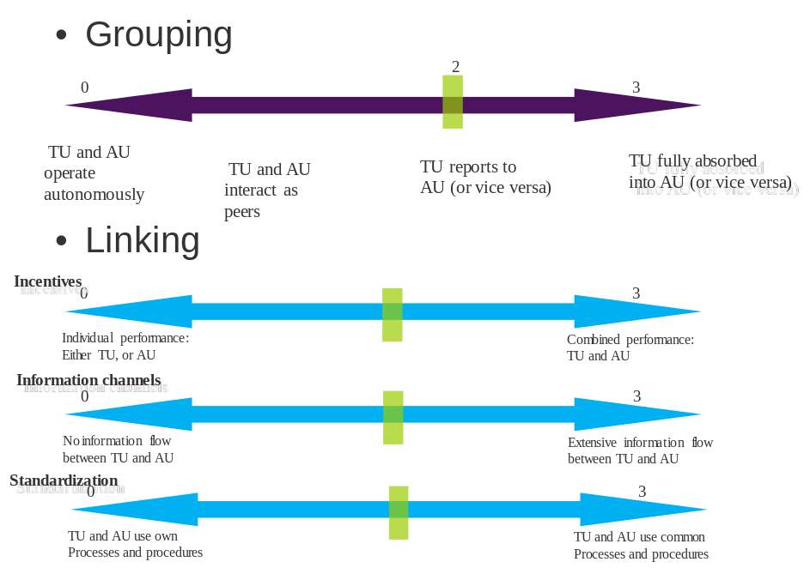
Figure 12.5 Grouping and linking choices in PMI

To consider these linking choices in more detail, think of them as lying on this spectrum:
- Incentives:
0: Continue to reward on individual unit’s performance, i.e. either target or acquirer ←→
3: Reward on combined target/acquirer unit performance

- Information channels:
0: No information flows between target and acquirer unit
←→
3: Extensive information flows between acquirer and target unit

- Standardization of work procedures:
0: Let target and acquirer continue to use own processes and procedures
←→
3: Switch to common process and procedures

Note that the grouping and linking choices are likely to be complements—the value of choosing low scores on the linking choices (incentives, information and standardization) is enhanced when a low score is chosen on the grouping choice and vice versa; conversely, choosing high scores on the linking choices goes hand in hand with choosing high scores on the grouping dimension (Figure 12.6). If this principle is violated, you should have a well thought through reason for this.

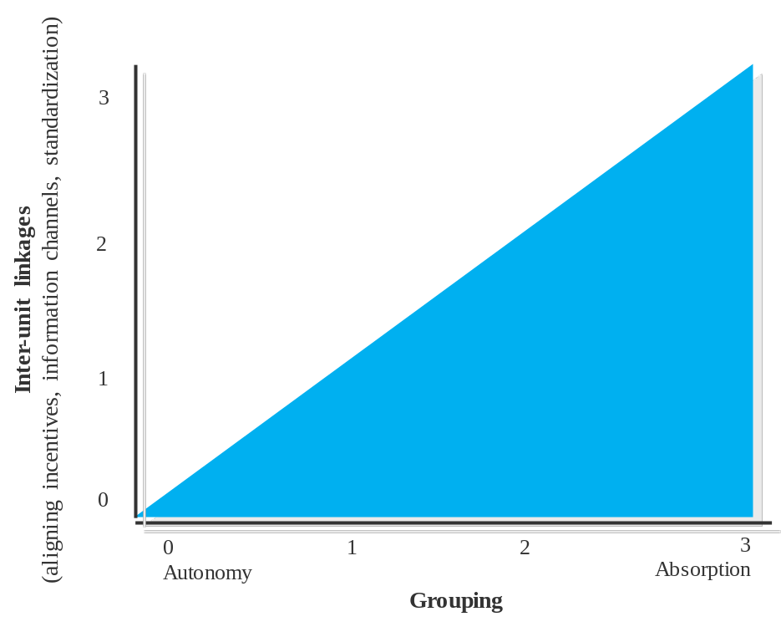
Figure 12.6 Grouping choices constrain linking choices

Where relevant and feasible, choices of geographic/physical location can reinforce or weaken the consequences of choices about organizational integration. These choices about where to locate the target organizational units within the acquirer’s organizational structure and in geographic space eventually also shape the informal organization that emerges between the target and acquirer personnel. They thus have long term consequences. If the target unit is left in its original location, then it is harder to implement high scores on all dimensions of linking and grouping. In contrast, relocating the target unit to acquirer unit location facilitates the implementation of higher scores and may indeed make high levels of integration less necessary (as informal interactions may suffice).

A framework for post-merger integration planning
Armed with these principles, we can introduce the basic framework for integration planning. The key principle behind this framework is that in every acquisition, each pair of organizational units from the acquirer and target could have a different optimal level of integration between them, based on the synergy operators that link them. The analysis has the following steps:

- Start with a clear statement of potential synergies between the acquirer and target (preferably the same one used to value the target). Understand exactly where and how the value chains of the two companies will join-up. Section 2 and the synergy operators are useful in this process.
- Identify the organizational units in acquirer and target associated with the affected value chain segments.
- Create a matrix with the organizational units of the target on the rows (see Figure 12.7), and the organizational units housing synergistic value chain segments of the acquirer on the other (based on synergies analysis above).
- In this Acquirer-Target matrix, for each cell, note the value of the synergies to be realized as estimated in the valuation phase.
- Finally, for each cell consider the first order (i.e., grouping) choices about organizational design, as well as the second order (i.e., linking) choices. Bear in mind the collaboration-disruption tradeoff when selecting the degree of integration.
- For each target unit (row), the integration level should not be more than that determined by the cell for which the synergies are greatest.
- You can choose to do the integration in phases. You can decide on a desired level of integration for Phase 1, achieve it, and then plan for the next level of integration in Phase 2. This is not the same as slow vs. fast implementation, in which the desired end state is known and we only vary the time taken to get there. Phase-wise integration can be very useful if you expect new information to emerge that may materially alter your plan for extracting synergies.

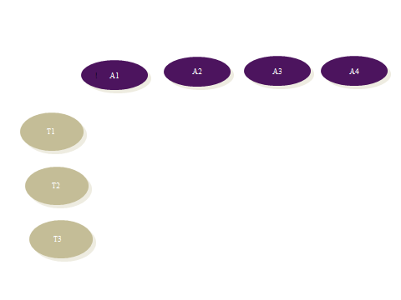
Figure 12.7 Post-merger integration matrix

The guiding principle for these choices may be stated as follows. In general, lower levels of integration (i.e. low scores on grouping and linking choices) are sufficient for low modification and dissimilar underlying resources. Thus the synergies requiring least and most integration, in that order are likely to be Connection, [Combination, Customization], Consolidation.

Application: TechnoSystems buys LittleCo
Consider the opening example of TechnoSystems acquiring the start-up software firm LittleCo. At this stage, we assume that the relevant synergies have been identified (see for guidance Section 2) and that the preferred growth mode is acquisition rather than alliance or organic growth (see Sections 4, 5, and 6). TechnoSystems wants to buy LittleCo primarily for Customization and Connection synergies; the technology must be made inter-operable with the acquirer’s suite of technologies, and will be sold by the acquirer’s sales force.

For the negotiation, we prepare a lower bound based on LittleCo’s stand-alone value and an upper bound based on the synergistic value between TechnoSystems and LittleCo. Because LittleCo is not listed, we cannot use a stock price as starting point. Instead, we could use a discounted cash flow approach (if sufficient information is available), and additionally as a sanity check, we could rely on the EBITDA multiple of peers (if LittleCo makes a profit) or their revenue multiple. Let’s say the valuation process leads to an estimate of stand-alone value at $100 million.

For the synergies, we rely on a discounted cash flow approach which suggests synergies (net of integration costs and appropriately discounted for risk and timeliness) of $60 million. These come mostly from revenue enhancements: selling the target’s products through the acquirer’s sales force ($43 million), from enhancing inter-operability of technologies ($15 million), and a modest cost saving from eliminating redundancy in sales force ($2 million). Thus, the bargaining zone lies between $100 and $160 million.

Without revealing the figure of $160 million during the negotiations, TechnoSystems uses past data on similar acquisition deals and IPO transactions to convince LittleCo that they should be taken over for $110 million.

This is a simple enough deal that we do not need a multi-phase integration approach. The integration matrix might look as below (scores are for the structural grouping decision and range from 0-autonomy to 3-full absorption):

TechnoSystems  LittleCo |  | R&D |  | Sales
R&D | Customization;  ($15 million)  Grouping level: [2] |  | Connection  ($43 million)  Grouping level: [1]
Sales | 0 |  | Consolidation  ($2 million)  Grouping level: [3]
Figure 12.8 Post-merger integration matrix for TechnoSystems and LittleCo

In this case the gains from inter-operability are less important than the gains from acquirer’s sales force cross-selling the target’s products. Therefore, it may suffice for the target R&D unit to be integrated to degree 1 with the acquirer’s sales force and also with the acquirer’s R&D unit. Choosing a higher level of integrating (i.e. degree 2) with acquirer R&D unit may create so much disruption that the synergy with acquirer sales unit is not realizable. In contrast, it is clear that the target’s sales force can be completely integrated into acquirer’s sales unit.

<APPLICATION ENDS>

Basic facts about M&As
- On average, acquirers do not benefit from an acquisition. Hundreds of studies have analyzed hundreds of thousands of acquisitions and found no noticeable effect (i.e., either positive or negative) on share price (short or long term), ROA, ROE, or ROS, on average. There is of course wide variance in outcomes.

- Most targets shareholders benefit from an acquisition. Typically, a take-over announcement is accompanied with a 30% increase in the share price. This means that the price the acquirer pays is much higher than what the target’s share price was before.

- On average, acquisitions generate value in the sense that the combined market capitalization of the acquirer and target go up. The increase is about 2% (reflecting the fact that acquirers tend to be bigger than targets). So whether M&As on average are beneficial depends on the perspective taken: acquirer, target, or society.

- In their meta-analysis on the effect of cultural differences on several outcome variables, Stahl & Voight (2008) report findings that show no systematic effect of culture on outcomes. One explanation lies in the selection of targets. Perhaps culturally different partners are only chosen when synergy extraction does not require intense collaboration. If so, then both culturally similar and dissimilar acquisitions may end up with comparable performance.

Common mistakes to avoid
- Do not go after just one target but have alternatives. Alternatives include alliances and organic growth. But even if you have decided on M&A, keep in mind to work with a short list of candidates. Treating a partner as unique may lead you to missing out on other valuable partners or to overpaying.

- When estimating the stand alone value of the target, use the target’s discount rate not the acquirer’s. A discount rate takes into account that cash flows are risky. The right risk level is that of the target not of the acquirer. Two implication of using the acquirer’s, and hence wrong, discount rate are: (1) the stand alone value of target would depend on the perspective taken (e.g. potential acquirer A would conclude a different stand-alone value than potential acquirer B, and (2) it would lead to overestimation of the stand-alone (and likely overpayment) value if the acquirer’s discount rate is lower than the acquirer’s (most acquirers are bigger than their targets, and discount rates tend to be lower for bigger firms).

- Do no treat PMI as all or nothing. Because integration involves a trade-off between benefits from collaboration and costs of disruption, typical integrations are rarely full integration or no integration at all. Further, an integration will look different for different parts of the organization.

- Do not wait with planning PMI until after a deal has been struck. Unless you are chasing an undervalued target, PMI is the justification for an acquisition. When considering whether the deal is worth it, you need to know what synergies are present and how those can be extracted. Furthermore, because implementation requires a lot of planning it is better to start early rather than later.

- PMI in more complex deals does not have to happen all at once. A multi-phase integration process, in which new information is expected to arise and is taken into account before formulating the next round of PMI plans can be very useful in complex transactions.

Frequently asked questions
Q1. What is the difference between integration and implementation?
Post-merger integration is the extent to which the different organizations are combined. Low integration for instance means keeping the acquired entity as an autonomous entity, often with its own profit and loss responsibility. High integration means it literally disappears off the organization chart. Intermediate levels of integration, with dense linkages between distinct organizational units (through integrating managers, committees, teams, processes, incentives) are also possible, and indeed are typical.

Thus “integration level” is the extent to which units across the two organizations will be put together. It could vary from “very little” to “very much”. And it could be different for different parts of the target organization.

Implementation is the process by which one gets to the desired level of integration. Implementation refers to the project management activities necessary to get to the desired level of integration. It includes linking IT, back office, payroll, HR etc. Communication is a key element as well.

There are arguments for both fast and slow (i.e. multi-phase) implementation Faster implementation may be better in terms of removing uncertainty about the steady state conditions that acquired employees face, and in generating the quick wins that lend confidence to both organizations that the merger can create value. However, there are also good reasons to implement more slowly: if the acquirer is yet to understand the target firms organization and sources of synergy, or if the key assets of the target firm are embedded in human capital, it may be better to postpone any potential disruption till at least some of these have been transferred to the acquirer. Thus, the speed of implementation must balance the benefit of waiting for more information and postponing disruption effects vs. the cost of uncertainty imposed on the organization and missed opportunities for extracting synergies in a gradual, multi-phase approach.

In this usage of the terms integration and implementation, partial implementation makes no sense, but partial integration may indeed be the optimal solution for a particular target. On the other hand “slow integration” does not make much sense with this usage, but slow implementation may be a sensible approach if it is valuable to delay the disruption effects for any desired level of integration, or collect additional information about the sources of value.

Q2. You have not mentioned culture much. Is this not important?
Culture is (very) important. We did not say much about planning for “cultural integration” because our view is that this is best achieved by selection rather than change.

To expand on this: First, clearly cultural differences matter in impeding effective collaboration between acquirer and target personnel. Differences in culture can create in-group/out-group suspicions and misunderstandings. Second, these are likely to be most salient when the synergies require close collaboration between partners- for instance more in the case of Customization and Consolidation, than in the case of Connection or Combination. Third, while robust methods to assess cultural differences between acquirer and target exist, and can be useful for anticipating cultural clashes, there are few robust techniques to engineer a desired culture. To assess differences in culture, a number of techniques including simple observation of how things get done, as well as more elaborate surveys or interviewing based methods exist to measure the differences in culture between organizations. However, to create a desired culture, while we know that retention, socialization, incentives, symbols, and leadership matter, these play out over larger time scales and feature a large degree of uncertainty.

For these reasons, we recommend that selecting targets that are culturally compatible, (particularly for synergies requiring high levels of collaboration), may be more useful than attempting to merge cultures after the deal has been done.

Q3. Are cross-border M&As different from M&As within a single country?
Yes and no.

No, because the basic decisions and trade-offs described in this section still apply: valuation provides a bargaining zone for negotiations, the grouping of organizational units depends on the synergies, and linking works in line with grouping.

Yes, because many of the problems we highlighted are exacerbated in an international context. Beginning with valuation, we have seen that a basic problem is obtaining reliable information and making reasonable assumptions. Our ability to do so might be lower for another country. Likewise, many companies struggle with PMI in a single country and the complexities of PMI are only compounded in an international context: cultures will be more different, geographical and time distances will lead to more misunderstandings, uncertainty will be higher, and regulation might be more restrictive.

Q4. In terms of share price, why does an acquirer typically not benefit from an acquisition but a target does?
First, acquiring is less painful for an acquirer than a target. If given a choice, most managers would prefer being an acquirer than a target. Hence, you would need to pay (heavily) for someone to take on the role of target.

Second, a target often has a strong alternative giving it the upper hand in negotiations. The synergies between an acquirer and target can often be replicated between the target and a different acquirer. If so, then the target can either implicitly or explicitly create a bidding contest for the company resulting in a high price. Hence, this is more a question of value capture than value creation.

Q5. If acquisitions provide little benefit for an acquirer, why do companies keep doing them?
To start with a caveat: precisely measuring M&A performance is difficult, and the high rates of failure of M&A may be somewhat exaggerated. But that said, if the failure rate is very likely at or above the 50% mark, what could be some reasons?

First, people make predictable errors when making decision. For example, one well known behavioral bias is that we are overconfident. So a CEO may acknowledge that many acquisitions fail, but not his or her own that he or she is about to do!

Second, many people are involved in the acquisition decision. It may not be a great outcome for shareholders, but it surely is for investment bankers, lawyers, and often too for acquiring CEOs (e.g., higher pay and more prestige).

Third, what’s the alternative? If companies want to grow, acquisitions do not necessarily perform well, but alliances and organic growth are also fraught with difficulties.

Q6. I am familiar with the integration framework of Haspeslagh and Jemison (1991): holding, preservation, symbiosis, and absorption. How is your approach different?
We too are familiar and inspired by their foundational work. We emphasize two additional points. First, the unit of analysis for the integration decision is the unit (e.g. department) rather than the firm. Thus, you can decide to integrate some departments and not others. Second, we make explicit that the timing of integration (e.g. in a multi-phase process) is a distinct decision from the degree of integration.

Q7. I understand how to calculate a price for an acquisition when I pay in cash, but what if I pay in stock?
Conceptually, there is no difference. As with a payment in cash, you begin with a valuation of the synergies. Here we consider that A acquires B using the example of the Appendix to Section 2. Assumptions are as before, and in addition, net debt is 90 for company A and 30 for B, the value of net debt remains the same after the acquisition, prior to the acquisition each company has 10 million shares outstanding, and A will pay B in newly issued shares. Figure 12.9 shows the equity value (= NPV – net debt) for each company with and without synergies. We assume that the calculated equity values per share equals the price the shares are trading for announcement of the acquisition.

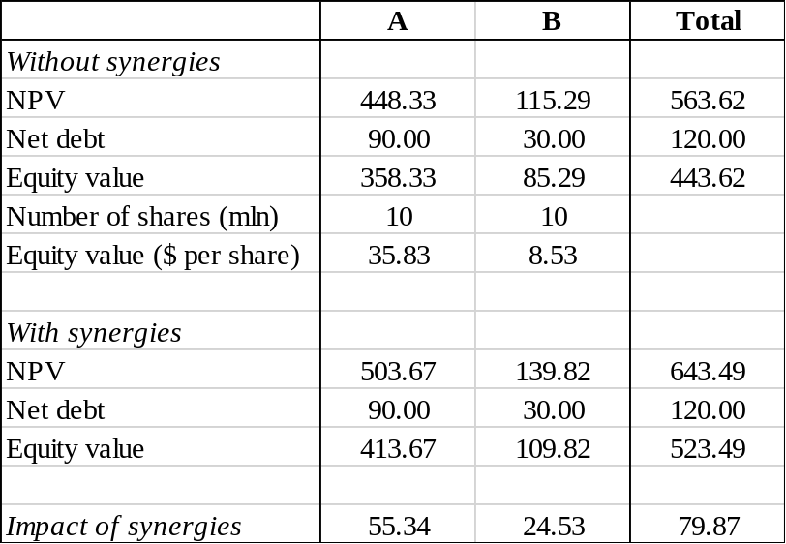
Figure 12.9 Valuation of synergies (all in mln $ except where noted otherwise)

Next, you will have to decide on a price, i.e., how the total expected synergies of 79.87 will be divided between A and B. Let’s say you represent the shareholders of A. At a minimum, you do not want to be worse off than before. The top row of Figure 12.10 shows the situation where A gets nothing and B gets all the synergies. This would increase B’s equity value from 85.29 to 165.16, which translates into a 94% premium on equity value for B (and 0% for A). Thus, the price offered for a share in B would be 94% more than the current value of the share, i.e., 16.52 (from 8.53). The currency used is A’s share, which is worth 35.83 (0% premium). Thus, each share of B is converted to almost half a share of A (16.52 / 35.83 = 0.46).

Likewise, B’s shareholders do not want to be worse off than before. The numbers are reversed, see the bottom row: A would get 100% of the synergies and B nothing. This implies a 22% premium per share for A and 0% for B. Thus, the price offered for a share in B is 8.53. The currency used is A’s share, which would be worth 43.82 (22% premium). Therefore, each share of B is converted to 0.19 share of A.

The bargaining zones is between these two extremes. You will prefer fewer shares offered for a share of B and use your bargaining skills to drive down the premium for B (e.g., by claiming that A will create more synergies than B, or pointing to a possible difference between actual share price and calculated equity value per share (without synergies)).

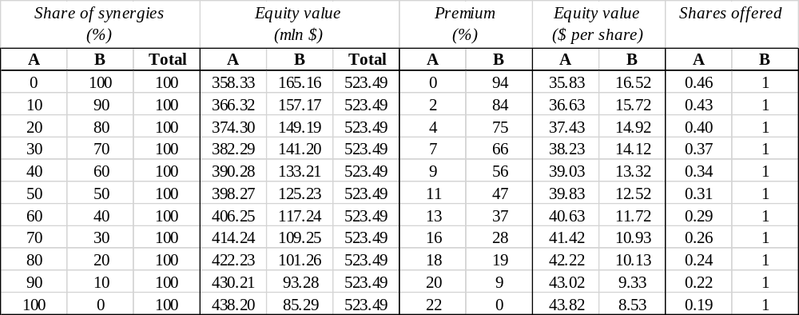
Figure 12.10 Division of synergies

Academic background
For more on PMI, see:
Capron, L., Dussauge, P., & Mitchell, W. (1998). Resource redeployment following horizontal acquisitions in Europe and North America, 1988-1992. Strategic Management Journal, 19(7), 631-662.
Capron, L., & Guillén, M. (2009). National corporate governance institutions and post-acquisition target reorganization. Strategic Management Journal, 30(8), 803-833.
Haspeslagh, P. C. & Jemison, D. B. (1991). Understanding different integration approaches. New York, USA: The Free Press.

For a further discussion on the trade-off between collaboration and disruption in post-merger integration, see:
Puranam, P., Singh, H., & Zollo, M. (2006). Organizing for innovation: managing the coordination-autonomy dilemma in technology acquisitions. Academy of Management Journal, 49(2), 263-280.
Puranam, P., & Srikanth, K. (2007). What they know vs. what they do: how acquirers leverage technology acquisitions. Strategic Management Journal, 28(8), 805-825.

For meta-analyses on M&A, see:
Haleblian, J., Devers, C. E., McNamara, G., Carpenter, M. A., & Davison, R. B. (2009). Taking stock of what we know about mergers and acquisitions: A review and research agenda. Journal of Management, 35(3), 469-502.
King, D. R., Dalton, D. R., Daily, C. M., & Covin, J. G. (2004). Meta‐analyses of post‐acquisition performance: Indications of unidentified moderators. Strategic Management Journal, 25(2), 187-200
Stahl, G. K., & Voigt, A. (2008). Do cultural differences matter in mergers and acquisitions? A tentative model and examination. Organization Science, 19(1), 160-176.

A merger of equals is the term used when two companies in a merger, or an acquisition, have similar ownership and control. Post-merger integration occurs in both mergers and acquisitions.
For more technical details about the various stages of the M&A process, refer for instance to Bruner, R. 2004. Applied Mergers and Acquisitions. Hoboken, USA: John Wiley and Sons.
For instance see Hawawini, G., & Viallet, C. (2011). Finance for executives: Managing for value creation (4th ed.). Mason, USA: South-Western, Cengage Learning. Narayanan, M. P., & Nanda, V. K. (2004). Finance for strategic decision-making: What non-financial managers need to know. Boston, USA: Jossey-Bass.
Andrade, G., Mitchell, M., & Stafford, E. (2001). New Evidence and Perspectives on Mergers. Journal of Economic Perspectives, 15(2), 103-120.

